8base Quick Start guide Report.

1. **Introduction.**At the beginning I did this task on Windows, but switched to Linux Ubuntu OS, because all commands in guide are written for Linux/MAC platforms. (And cause Linux is the best OS of course).  
   The report is in three parts:  
   Progression – Quick Guide steps with screenshots;  
   Environment and Migrations – additional task;  
   Bug-reports – bugs that I caught;  
   Feedback – suggestions for improvement/problems I had.
2. **Progression.**
   1. **Setting up a Workspace.**  
      Create fields and relationships between tables.  
      Изображение выглядит как текст, снимок экрана, внутренний

      Автоматически созданное описание  
      GraphQL mutation.

Mutation result.  
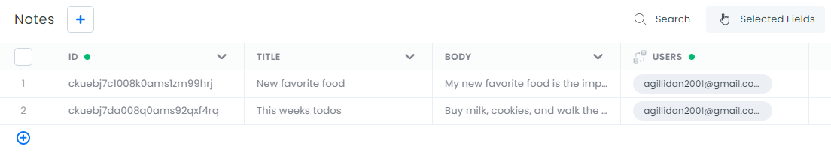  
Add Reviewer role and setup permissions.  
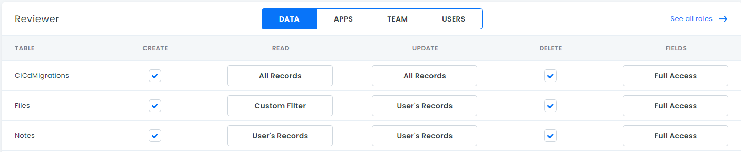  
Create Authentication profile.  
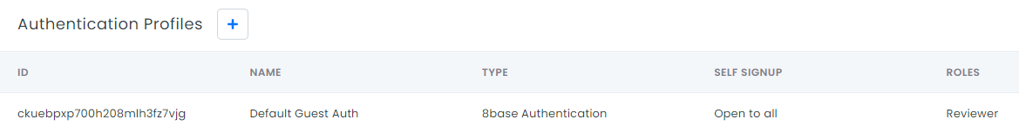

* 1. **Setting up the Client.**  
     Make folders.  
       
     Move into project and add README.md.  
       
     Install 8base globally.  
       
     Login.  
       
     Init the new 8base project with myCustomResolver function.  
       
     Install dependencies.  
       
     Configure the project’s workspace.  
       
     Deploy.  
       
     Invoke function in production.  
       
       
       
     Clone React project from github.  
       
     Install npm and copy .env.  
       
     Set environment variables (by vim).  
     Изображение выглядит как текст

     Автоматически созданное описание  
     Run the app.  
       
     Result.  
     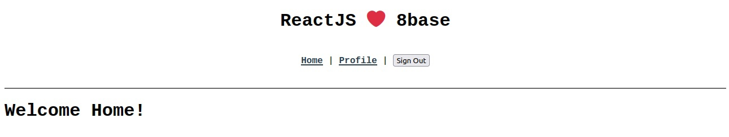

1. **Environments and Migrations.**Create a new environment.  
     
   Show current branch.  
   Изображение выглядит как текст

   Автоматически созданное описание  
   Switching between Environments.  
   Изображение выглядит как текст

   Автоматически созданное описание  
   Delete environment.  
     
     
     
     
     
   Generate migration.  
   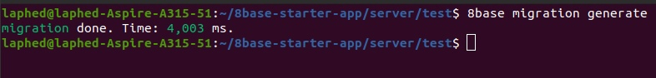  
   Commit migration.  
     
   Simple bash-script for committing process.  
   Изображение выглядит как текст

   Автоматически созданное описание
2. **Bug-reports.**
   1. Description: Links to workspace pages (Data Builder, API Explorer, Authentication page) redirect to <https://app.8base.com/developer-home/workspaces> page.  
      Procedure: Click on Data Builder, API Explorer, Authentication page links on <https://docs.8base.com/docs/getting-started/quick-start> page.  
      Screenshots (optional): -
   2. Description: Incorrect screenshot in Authentication topic. There is old way to Authentication (Settings > Authentication), true way is App Services > Authentication.   
      Procedure: Open screenshot from Authentication topic. Direct link: <https://docs.8base.com/assets/static/qs-auth-profile.2665e34.a1c5f2dce96bda1eaafc2bcd341553e2.png>  
      Screenshots (optional):   
      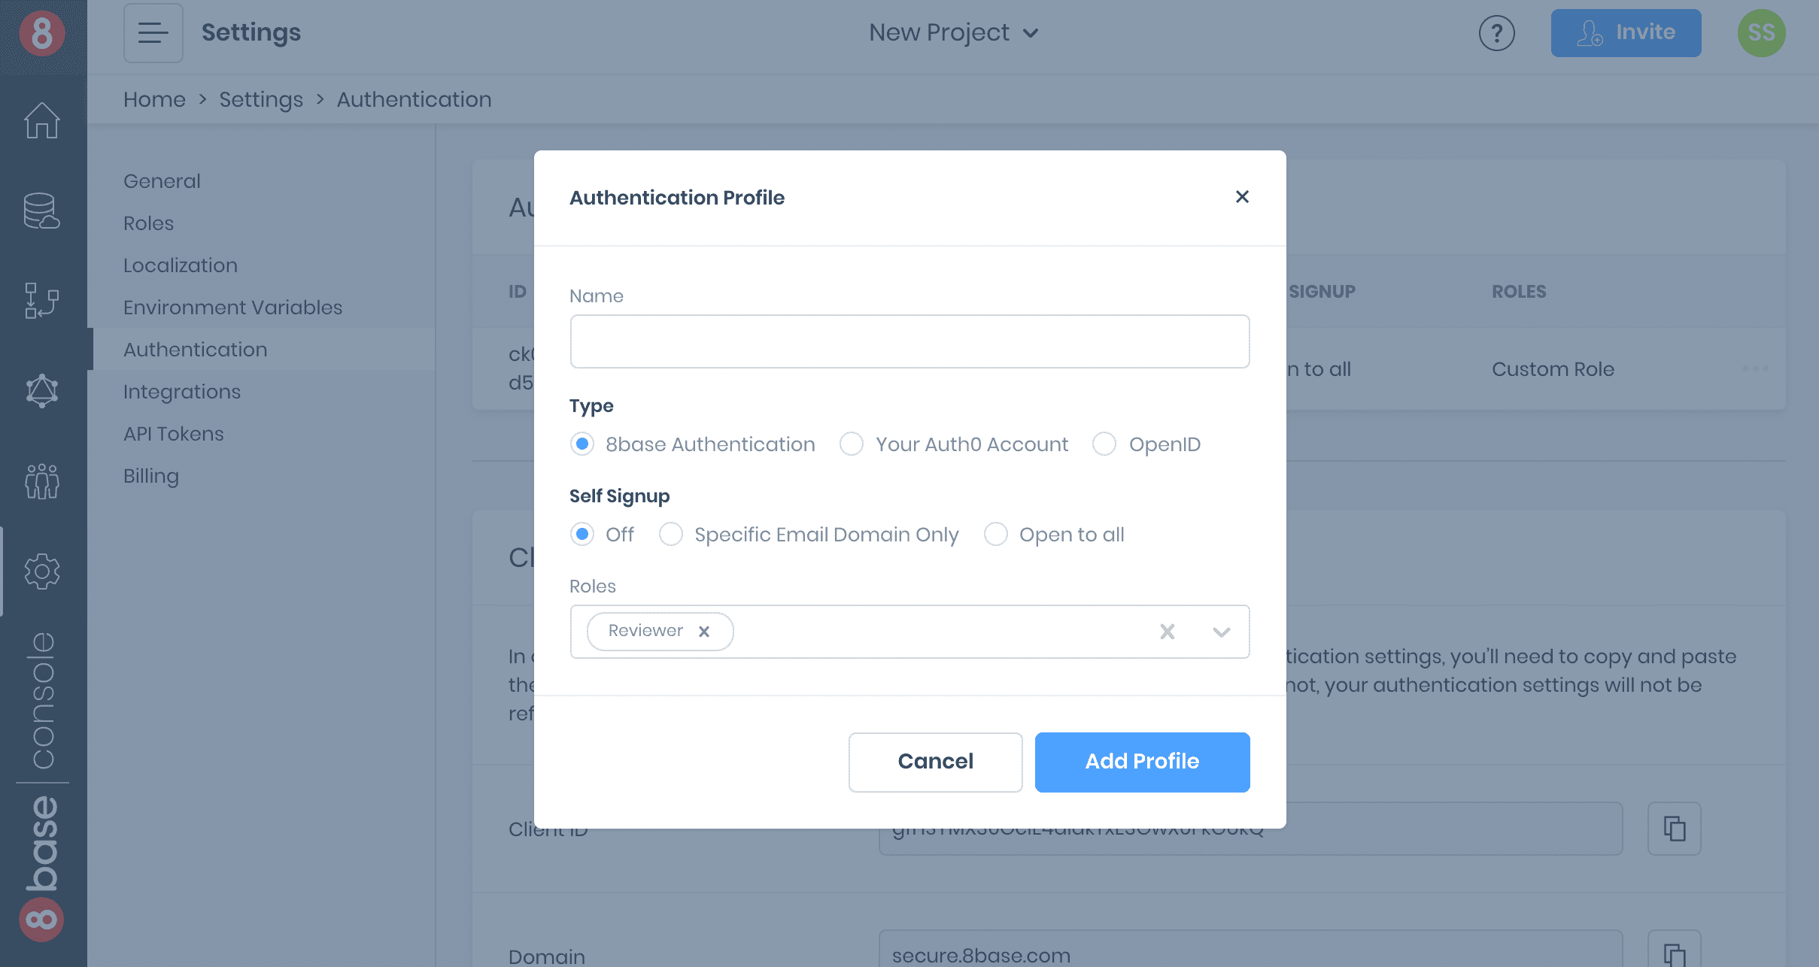
   3. Description: Installing dependencies to ReactJS Starter App makes 5 vulnerabilities.  
      Procedure: execute **git clone** [**https://github.com/8base/react-8base-starter-app.git**](https://github.com/8base/react-8base-starter-app.git)  
      execute **cd react-8base-starter-app**execute **npm install**  
      Screenshots (optional):   
      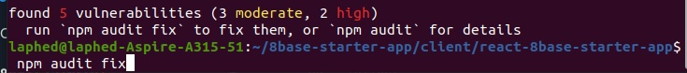
   4. Description: Init command doesn’t work on Linux OS.  
      Procedure:  
      run Linux OS  
      execute **mkdir 8base -starter-app 8base-starter-app/client 8base-starter-app/server**execute **cd 8base-starter-app && touch README.md**execute **cd server && 8base init . –functions=myFunction**  
      Screenshots (optional):  
      
3. **Feedback.**Quick Start guide is good but isn’t perfect. There aren’t commands for Windows cmd. You can make three options (MAC/Linux/Windows) for each block with commands. This guide has some problems with usability. For example,

Up to this point you write all terminal commands in special blocks, but in this case you print **8base deploy** outside the block. At first time I skipped it.  
Also I wasted time to finding information for .env file, it wasn’t intuitive for me. You can write that Client_ID, Domain and Profile_ID are in the Authentication window.